TTL LOGIC CIRCUITS

1. OBJECTIVES
This laboratory work presents the constructive functioning characteristics of the TTL integrated circuit’s family, and the main static and dynamic parameters of this family.

2. THEORETICAL CONSIDERATIONS
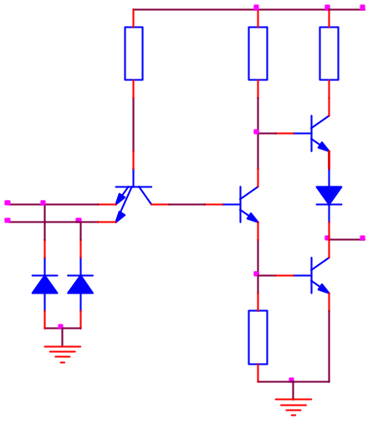
2.1 Functioning of the circuit
Q₁
Q₂
Q₃
Q₄
D₂
D₁
D
R₂
1,6K
R₁
4K
R₄
130
R₃
1K
V_{CC}
A
B
y=AB
U_{e}
Fig.2.1
To show the electric functioning of the circuit in figure 2.1, let’s assume first that one of the inputs is connected to the ground (logic level "0"). As a consequence, Q₁ transistor is saturated, and because of the voltage drop in it’s collector, Q₂ transistor is cut-off stage. The low voltage in Q₂’s emitter determines the blocking of the Q₄ transistor. The Q₃ transistor will be in conduction, being driven by the high potential in Q₂’s collector. At the output we will obtain a high voltage, corresponding to “1” logic level.
If at both inputs we apply a voltage corresponding to “1” logic level, the basis-emitter junctions of the Q₁ transistor are reversed biased and the transistor works in the reverse active stage. In this case the basis-collector of the Q₁ transistor and the basis-emitter junctions of the Q₂ and Q₄ transistors form a chain of directly polarized diodes through the R₁ resistance from the plus of the voltage source. As a consequence the Q₂ and Q₄ transistors will become saturated. In the same time the Q₃ transistor is blocked because in it’s basis there is a smaller potential than in it’s emitter because of the voltage difference introduced by the D₃ diode. Thus we obtain at the output a potential equal to Q₄’s collector-emitter saturation voltage which corresponds to “0” logic level.
If we analyze the functioning of the gate from the logical point of view, we observe that it realizes the NAND function, so: 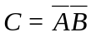
2.2 Circuit parameters
Logical levels: V_{ILmax} = 0.8 V, V_{IHmin} = 2 V, V_{OLmax} = 0.4 V, V_{OHmin} = 2.4 V and V_{T} = 1.3V
Noise margins: M_{L} = 0.4V and M_{H} = 0.4V
Input and output currents: I_{IH} = 40 μA, I_{IL} = -1,6 mA, I_{OH} = -800 μA and I_{OL} = 16 mA
Fan out: FO_{L} = 10, FO_{H} = 20 and FO = 10
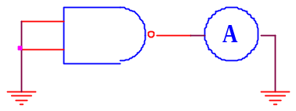
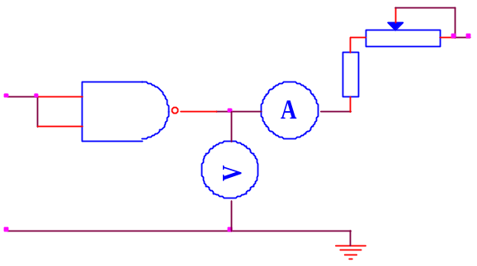
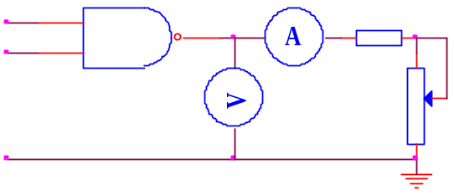
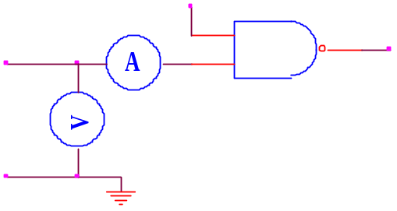
The input characteristic I_{I}=f(V_{I}), can be obtained using the scheme in figure 2.2.
Fig.2.5
V_{IH}
V_{O}
I_{OL}
150
400
V_{CC}
Fig.2.3
V_{IL}
V_{O}
I_{OH}
1K
10K
V_{IH}
Fig.2.4
V_{IH}
V_{O}
V_{I}
Fig.2.2
The output characteristic V_{OL}=f(I_{OL}) can be obtained using the scheme in figure 2.3 and the characteristic V_{OH}=f(I_{OH}) with the scheme in figure 2.4.
The short circuiting of the output to the ground can determine a current between 18 and 55 mA, through the Q₃ transistor, if Q₃, D₃ and R₄ work statically correct. This current is not dangerous if it has a short period. The variation of the short circuit with the supplying voltage can be observed using the scheme in figure 2.5.
In the TTL integrated circuits family there are several series of circuits, which differ one from another by the compromise between the power consumption on the gate and the propagation time, as shown in the table below:
 | 74 | 74LS | 74S | 74ALS | 74AS
Typical static power consumption/gate [mW] | 10 | 2 | 19 | 1.2 | 8.5
Typical propagation time [ns] | 10 | 9.5 | 3 | 4 | 1.5
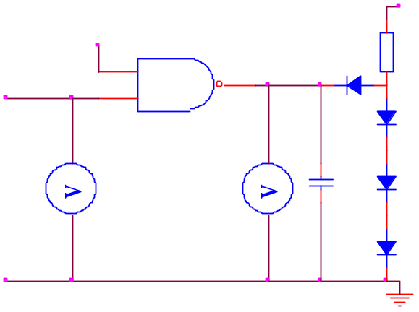
The transfer characteristic of the NAND standard gate can be plotted using the layout presented in figure 2.6. The circuit formed by R₁, D₁-D₄, connected to the gate output simulates an impedance equivalent to 10 TTL charges. The diodes are of 1N4148 type and C₁ includes the output capacitances of the probes and of the connecting system.
V_{I}
V_{O}
V_{CC}
R₁
400
C₁
15pF
V_{IH}
D₁
D₂
D₃
D₄
Fig.2.6
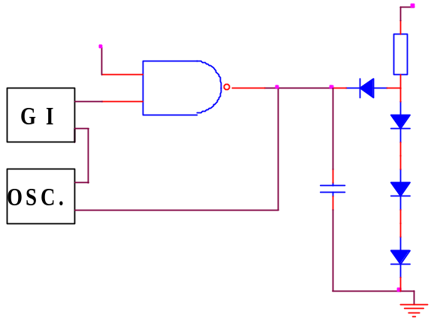
The dynamic characteristics of the TTL circuits can be determined using the circuit in figure 2.7, which simulates the loading of a gate with 10 TTL charges. The rising and falling times t_{r} and t_{f} have the typical values 8ns and 5ns respectively. The propagation time have the following typical values: t_{pHL}=8ns, t_{pLH}=12ns and t_{p}=10ns.
V_{IH}
D₁
C_{S}
15pF
V_{CC}
R₁
D₂
D₃
D₄
Fig.2.7

3. PRACTICAL APPROACH
3.1. Using the circuit in figure 2.6, the transfer characteristic of the TTL gate is plotted. The guaranteed output levels function of the admissible input voltage levels are checked.
3.2. Using the circuit in figure 2.2 the input characteristic is plotted.
2.3. Using the circuit in figure 2.5 the short circuit current of the fundamental TTL gate is determined.
2.4. Using the circuit in figure 2.1, if one input is kept at 5V and the other one is changed between 0V and 5V and then between 5V and 0V, the current absorbed from the voltage supply is viewed.
2.5. Using the circuit in figure 2.1, if one input is kept at 5V and the other one is changed between 0V and 5V and then between 5V and 0V the voltages in the entire circuit are viewed. Based on this graphs the circuit’s functioning will be explained.
2.6. Using the circuit in figure 2.7 the dynamic behavior of the circuit will be analyzed.

4. THE CONTENT OF THE REPORT
  - The brief presentation of the TTL circuits’ characteristic.
  - The schemes of the circuits, the tables with calculated values and the graphs representing the plotted characteristics.
  - The graphs obtained at the analysis of the TTL circuits’ dynamic behavior.
  - Remarks on the nature of the differences between the theoretic values and the simulated results.

